St. Francis Institute of Technology, Mumbai-400 103

**Department Of Information Technology**

A.Y. 2021-2022

Class: TE-ITA/B, Semester: VI

Subject: **Web Lab**

**Experiment – 1: To study web analytics using open source tools like Matomo, Open Web Analytics, AWStats, Countly, Plausible.**

1. **Aim:** To study open source Web Analytics tools
2. **Objectives:** Aim of this experiment is that, the students will be able

* To Understand open source tools for web analytics in web apps development and deployment

1. **Outcomes:** After study of this experiment, the students will be able

* To understand the importance of web analytics.
* Learn about various open source tools for web analytics
* To have an introduction to web semantics

1. **Prerequisite:** Knowledge of digital web evolution,
2. **Requirements:** Personal Computer, Windows operating system, browser, Internet Connection, google doc.
3. **Pre-Experiment Exercise:**

**Brief Theory:** Refer shared material

1. **Laboratory Exercise**
   * + 1. **Procedure:**

**a. Answer the following:**

* Define web and compare with term Internet.

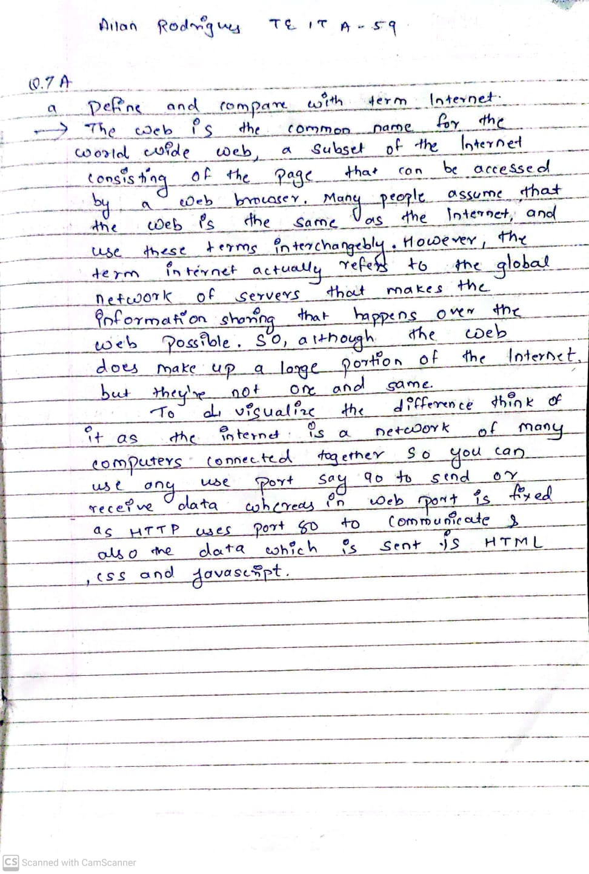

* What is a Web based application?

A Web application (Web app) is an application program that is stored on a remote server and delivered over the Internet through a browser interface. Web services are Web apps by definition and many, although not all, websites contain Web apps.

Web applications can be designed for a wide variety of uses and can be used by anyone; from an organization to an individual for numerous reasons. Commonly used Web applications can include webmail, online calculators, or e-commerce shops. Some Web apps can be only accessed by a specific browser; however, most are available no matter the browser.

Web applications do not need to be downloaded since they are accessed through a network. Users can access a Web application through a web browser such as Google Chrome, Mozilla Firefox or Safari.

For a web app to operate, it needs a Web server, application server, and a database. Web servers manage the requests that come from a client, while the application server completes the requested task. A database can be used to store any needed information.

* Compare desktop application with web based application?

|  |  |
| --- | --- |
| Web Applications | Desktop Applications |
| * Deployment and up-gradation for a web-based application require deployment on a single set of server machines. | * Deployment and any up-gradation/patch are done on individual client machines separately. |
| * Web applications can be accessed from anywhere, so there is no location constraint. | * As desktop are confined to a standalone machine, so they can be only accessed from the machines they are deployed in. |
| * Web applications are platform-independent, they can work in different types of platforms with the only requirement of a web browser. | * Desktop applications need to be developed separately for different platform machines. |
| * Web applications are at higher security risks as they are inherently designed to increase accessibility. | * Desktop applications, on the other hand, have better authorization and administrators have better control, hence more secure. |
| * Web applications rely heavily on internet connectivity, for there operation. | * Desktop applications don’t require the internet for their operations. Some applications just require internet connectivity at the time of updates. |

* Compare Google analytics with Countly,Plausible, Matomo-

|  |  |  |  |  |  |
| --- | --- | --- | --- | --- | --- |
| sr no | parameter | Google Analytics | Countly | Plausible | Matomo |
|  | Session | A session in  Google Analytics  is a group of  interactions  recorded when a  user visits your  website within a  given period | Each launch  of the  application or  a visitor  landing on a  web page. | Show how much  time an  individual spend  on average on  specific pages | Session  Recordings  lets you record  all activities on  a page of a real  visitor such as  clicks, mouse  movements,  scrolls,  window  resizes, page  changes, and  form  interactions |
|  | Total Visitors | Number of  users who  have initiated  at least one  session during  the date range | Number of  unique visitors  to a website  for a selected  period. | The number of  people who  visited the site.  This tool is  privacy friendly  so they don't use  cookies and  other persistent  identifiers. If a  person visits  from multiple  devices or on  multiple days,  they are counted  as separate  visitors | The number of  unduplicated  visitors  coming to your  website. Every  user is only  counted once,  even if he  visits the  website  multiple times  a day. |
|  | Returning Users/Visitors | A user who returns  to a site by using  the same browser  or same computer  or device | Number of  users that  have used the  application at  least once  before. | One of the  biggest  limitation with  is that Plausible.  cannot do good  retention  analysis. It  cannot show  stats like New vs  Returning visitors because  they rely on  having a  persistent user  identifier | Visitors  marked as  returning  visitors:  1.  They have  visited the  website at least  once before  this visit and both visits  were made  using the same  browser and  with tracking  cookies  enabled. |
|  | Average Request Received | The limits and  quotas of  requesting the  Management APIs  and Reporting  APIs. It put limits  and quotas on API  requests to protect  the system from  receiving more  data than it can  handle, and to  ensure an equitable  distribution of the  system resources | Number of  write API  requests  Countly  Server  receives for  each session | API keys have a  rate limit of 600  requests per hour  by default | The Request  class is used  throughout  Matomo  (formerly  Piwik) to call  API methods. |
|  | Time Spent | Measures how  long a user  spent on the  site in total | Total time  spent on the  website for  the selected  time period | The average time  people spend on  a particular page  on your site. This  is calculated as  the difference between the  point when a  person lands on a  particular page  and when they  move on to the  next page. | By default,  Matomo  (Piwik) will  accurately  track the time  spent on all your pages,  except the last  page view of  the visi |

**b**. **Attach screenshots:**

* Web Evolution

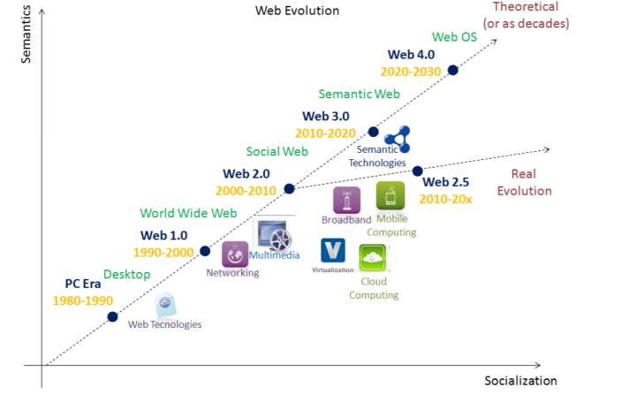

* Google Analytics home page

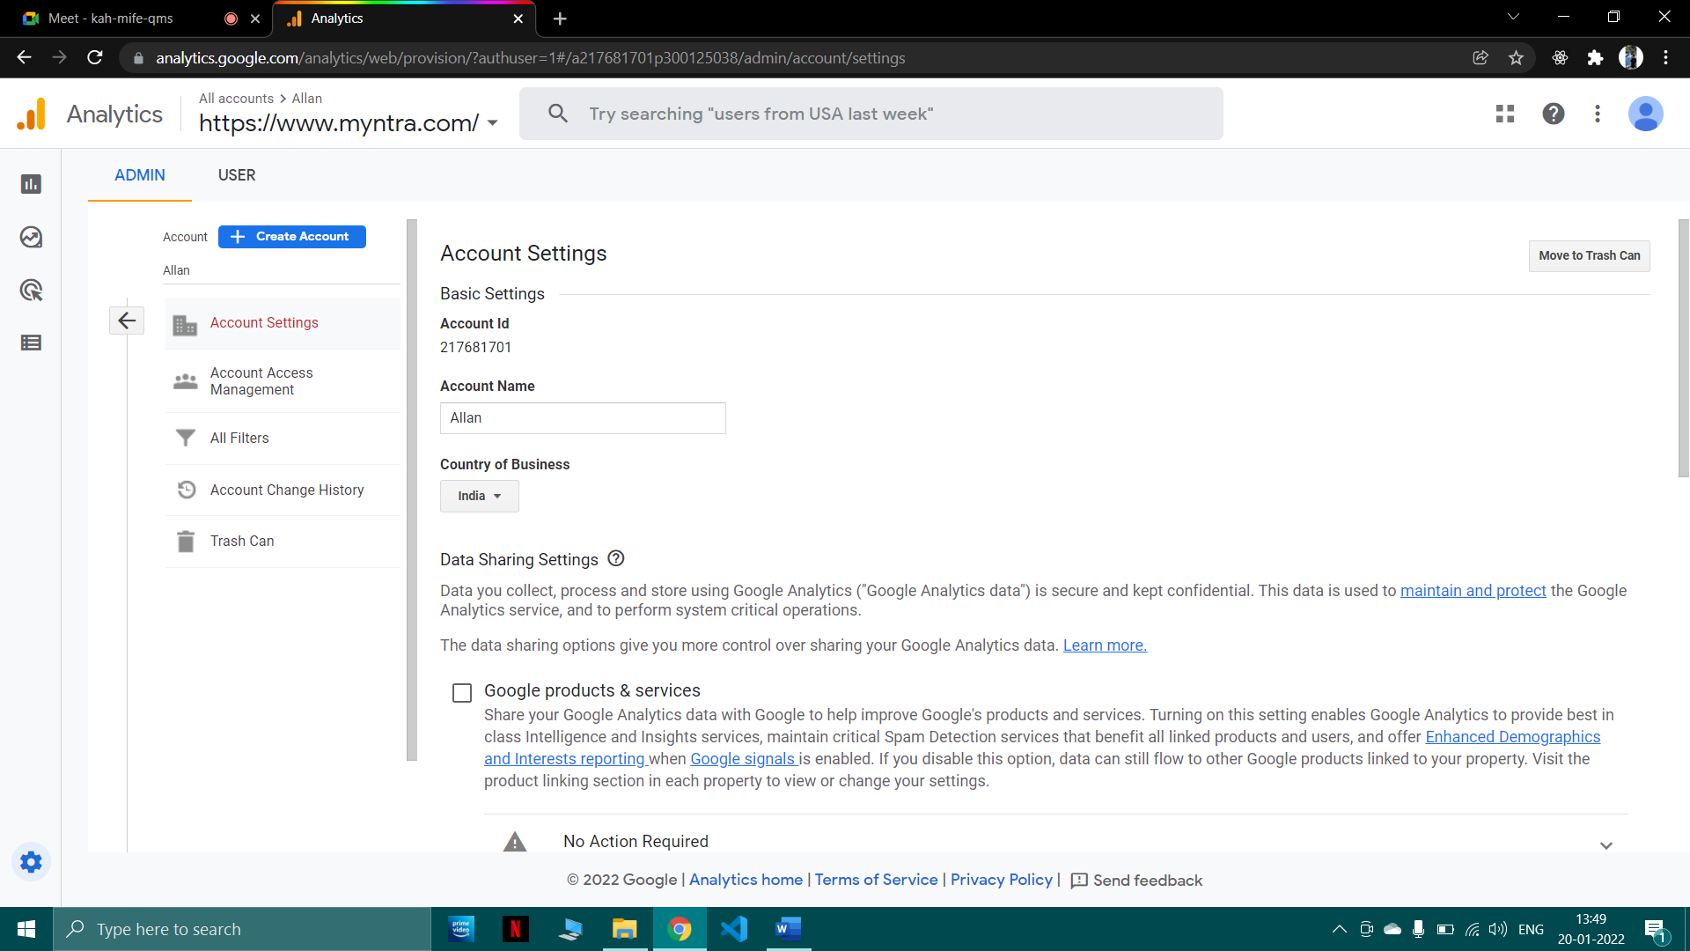

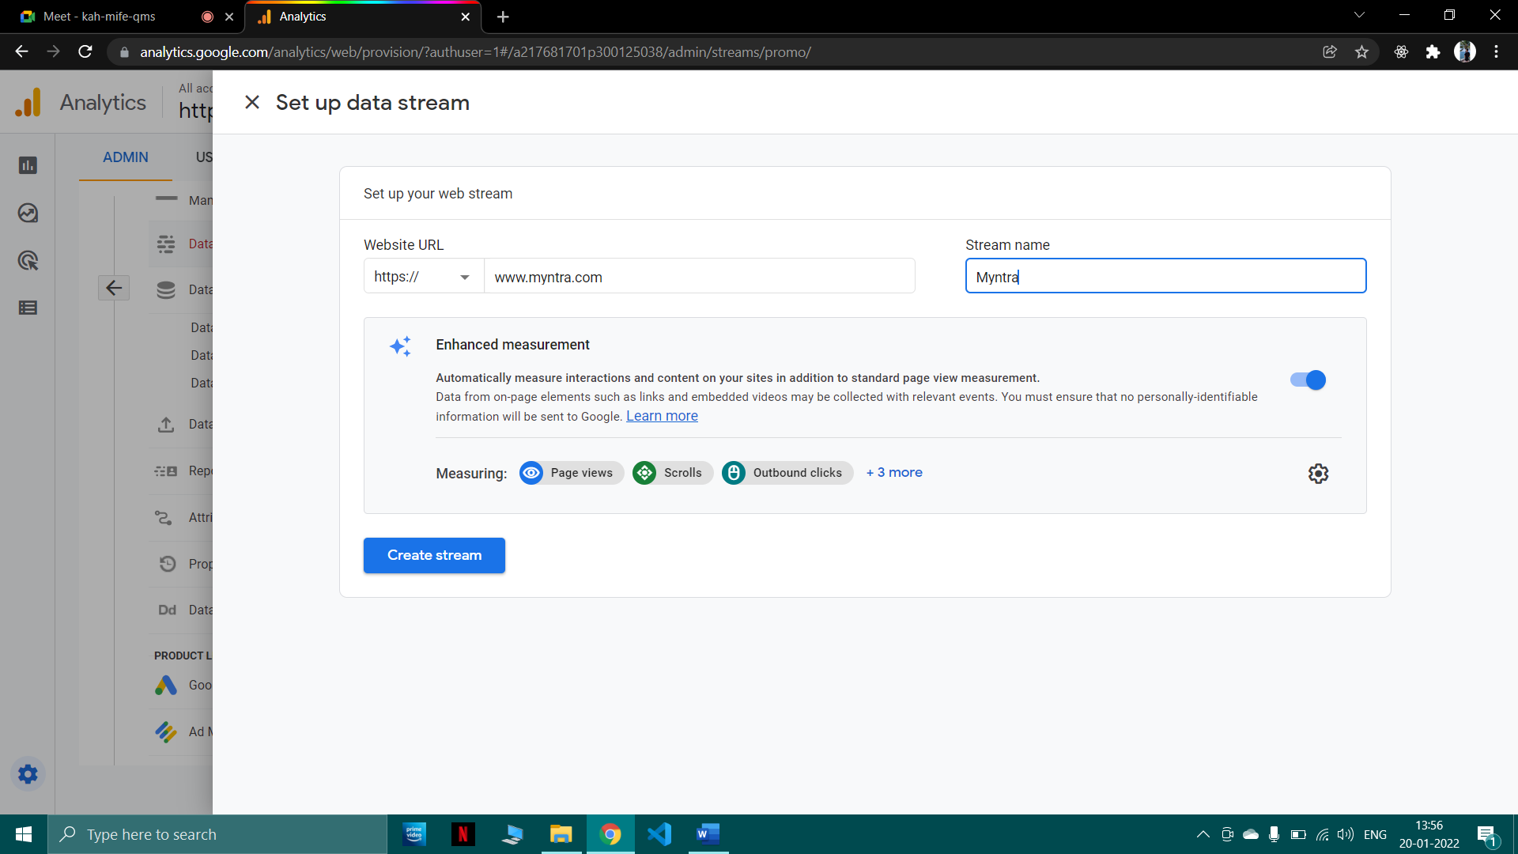

* Matomo user interface

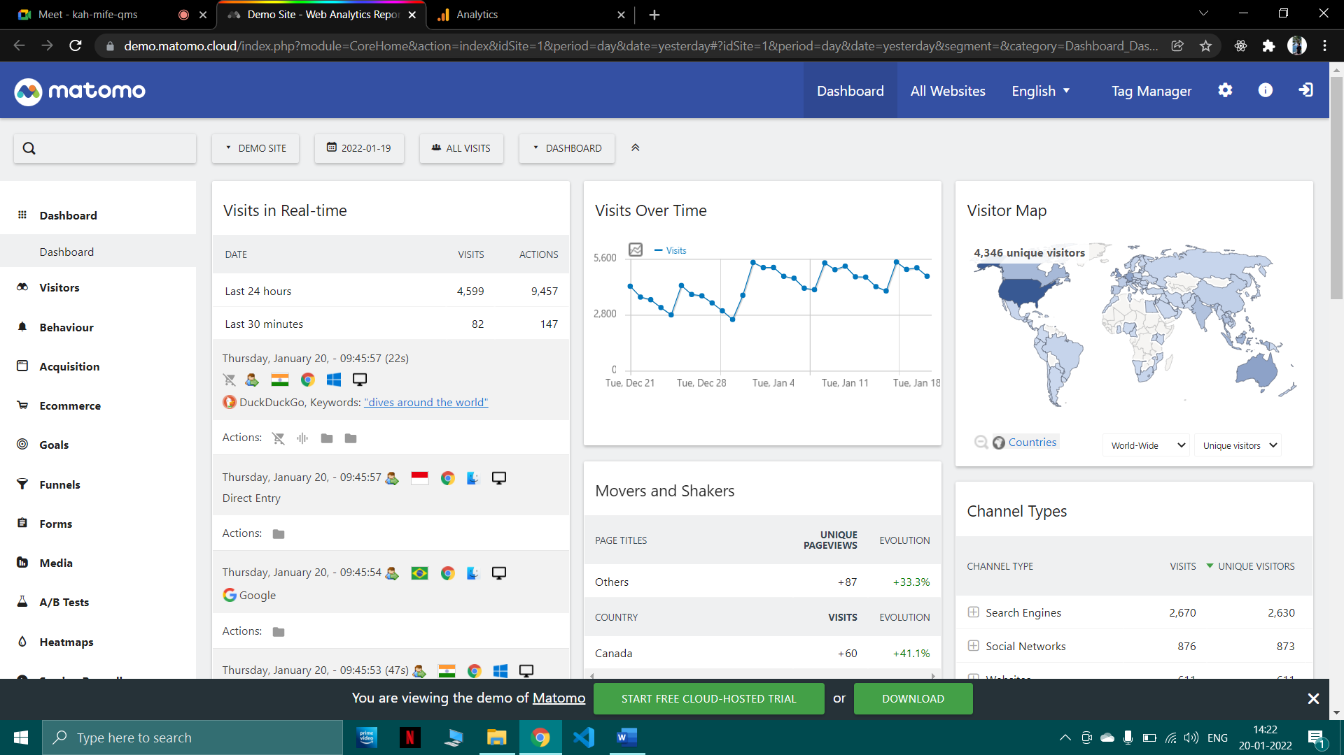

1. **Post-Experiments Exercise**
2. **Extended Theory:**

Nil

1. **Questions:**

* Write in tabular form main characteristics of each Web generations (web theme, technologies, level of functionalities, key differences)

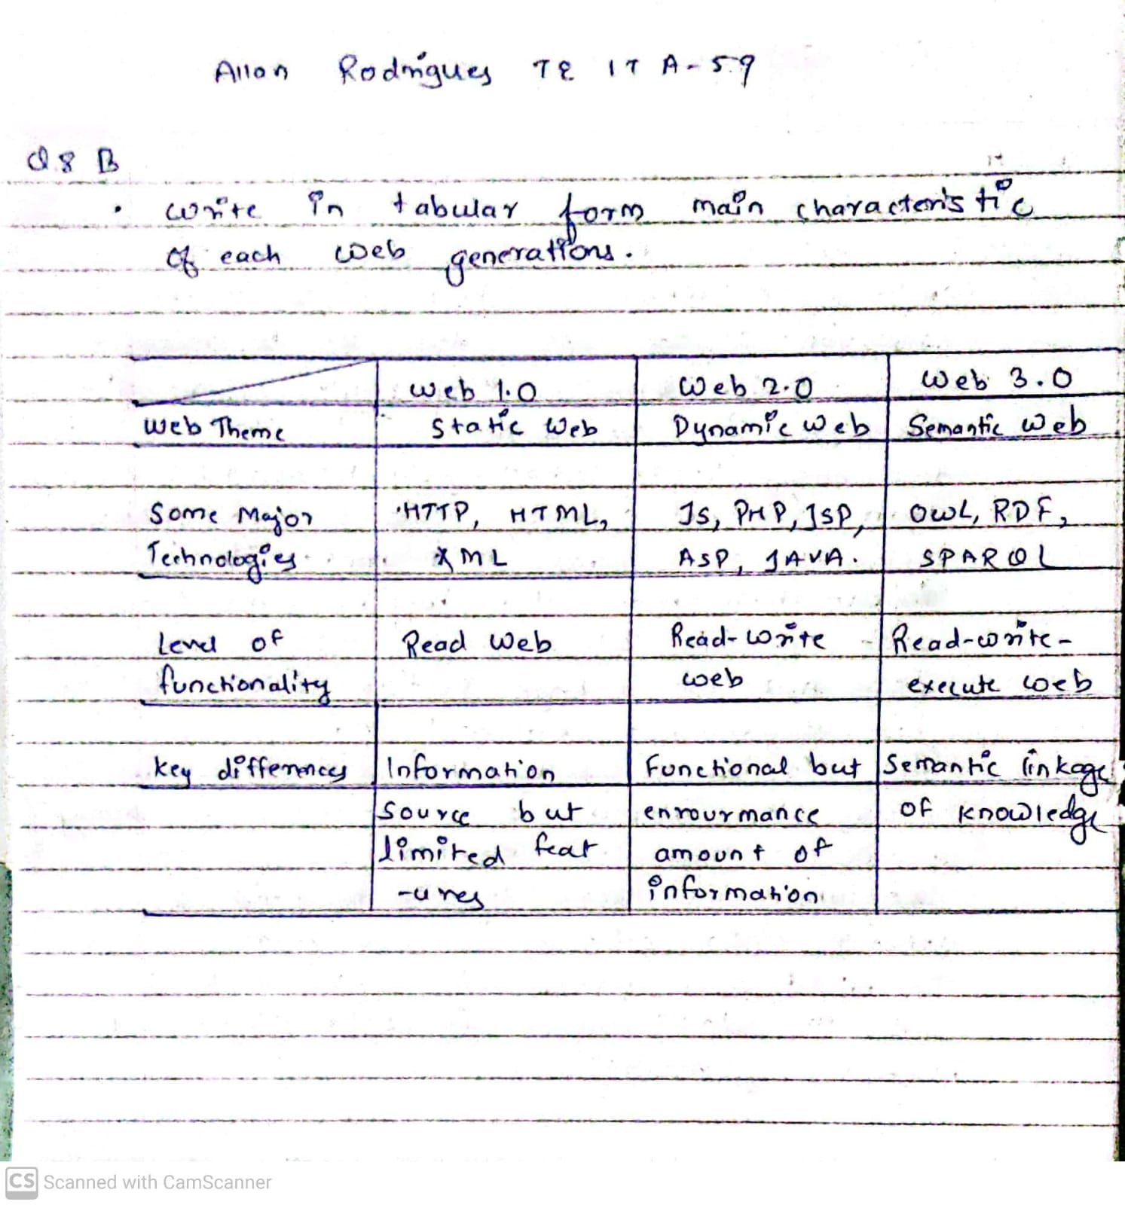

* What are the steps to create a funnel in countly?

Funnels in Countly are an intuitive way of tracking and analyzing user behavior. This guide provides a quick overview of their setup and capabilities.

Creating a Funnel

First of all, you must enable Funnels in the Countly Dashboard by going to Management > Plugins in the top-right corner. You will then find Funnels under the Behavior category of the Explore section of your Dashboard.

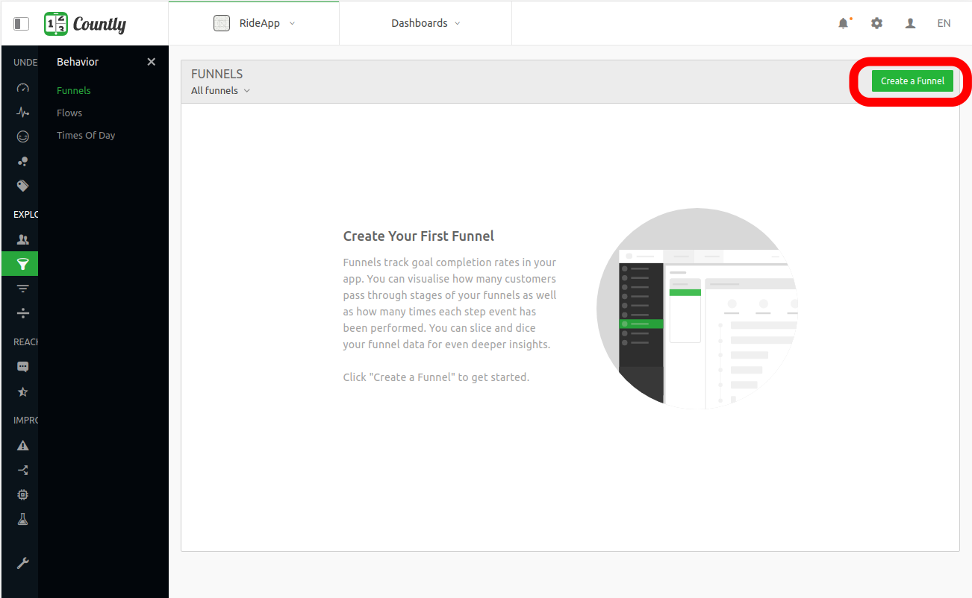

If you have not created a funnel yet, you will see an empty funnel page with a description. You need to click on the Create a Funnel button on the top-right corner of the Funnels overview page.

When you click on the Create a Funnel button, the Create a Funnel drawer will prompt.

Funnels require a minimum of 2 steps and up to 8 steps which is configurable from Management > Configurations. You can increase the number of steps as you like, and you can discover at which step users are stuck or getting problems.

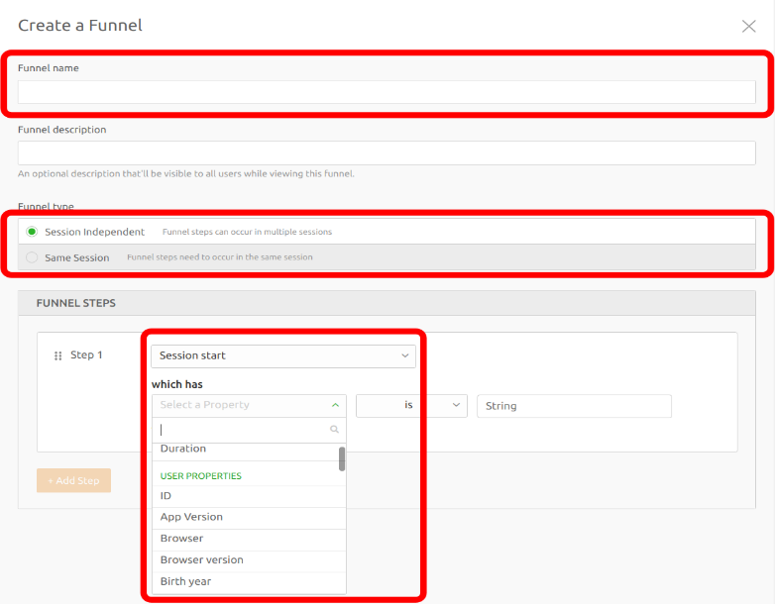

Funnel Name: You must give your funnel a name to create it, while funnel description is optional.

Funnel Type: This helps you configure the session dependence of your funnel.

Funnel Steps: You can define the steps of your funnel by either inputting the event key you plan to send in the future or selecting one from your existing events.

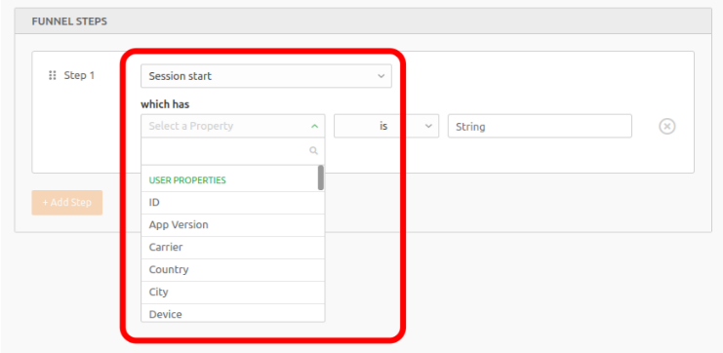

When you select an existing event as the first step, the add property link button will appear, letting you add a segmentation filter for your funnel step. For example, if you add the segmentation filter count is 2, you will see funnel users who completed this particular event two times. Similarly, you can select the City user property to filter the completion of the event by location. You can keep adding segmentation filters to each step of the funnel for more precise targeting.

For example, say you have an e-commerce website. When your users enter a product page ("Detail View Level 1") you want to know the selling rate of this product for users from a specific country.

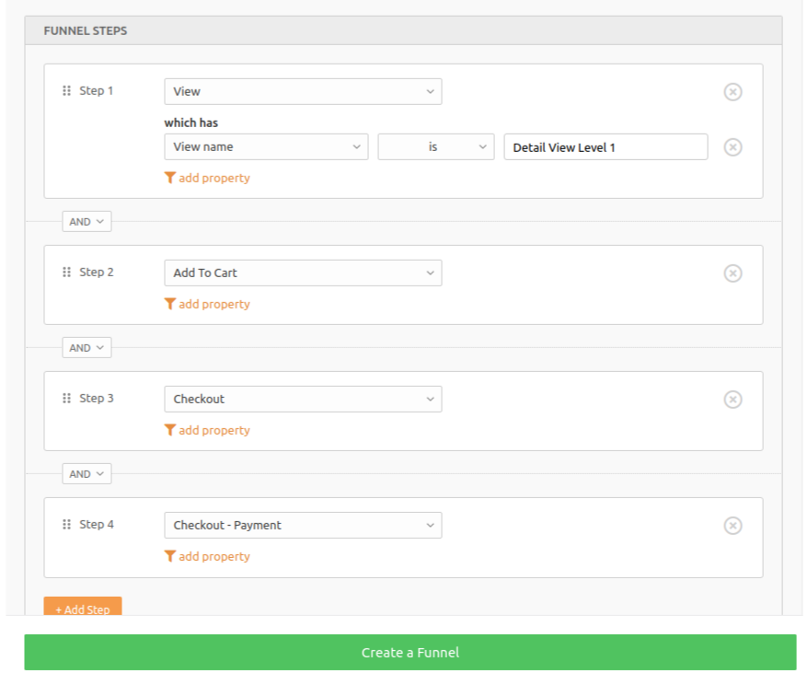

The steps you need to set are:

Define an event for the buttons to this product page

Define an event for the "add to cart" button on this page

Define an event to track when it goes to the checkout page

Define an event for when the order is completed

Session Dependence

By default, funnels capture all users who complete a series of events, regardless of the session to which those events belong. In other words, events taking place in the exact order you determined is enough for considering that a user completed that funnel. These type of funnels are called "Session Independent".

A user must do all steps of the funnel to be regarded as having completed the funnel. In some cases, however, this can be too restrictive.

For instance, you may need a 3-steps funnel, where the second step can be either adding an item to cart or redeeming a promotion code. In other words, you may need to define a funnel that accepts both of these paths:

1. View > Add to Cart > Checkout
2. View > Promo Code > Checkout

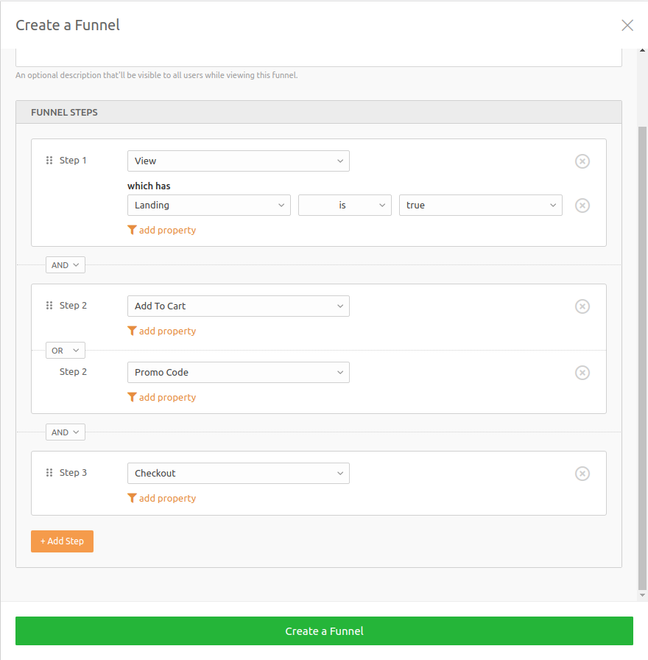

In order to accomplish that, you simply change AND, which is between Add To Cart and Promo Code, to OR. This will merge both steps and convert them into a group of steps. Consequently, users who have done at least one of the above paths (1 or 2) will complete the same funnel.

* Give important KPI of web analytics.

The top eight key performance indicators to track on your website

1. Bounce Rate

2. Unique Website Visitors

3. Pages Viewed Per Session

4. Average Time on Page

5. Top Landing Pages

6. Top Exit Pages

7. Goals and Event Completions

8. Onsite Search Queries

1. **Conclusion:**

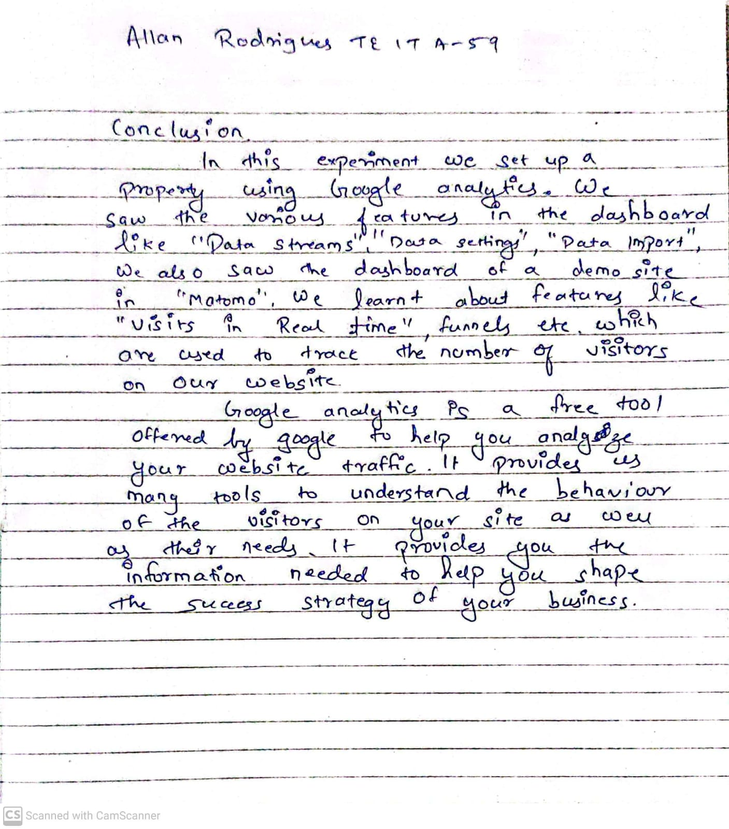

1. **References:**
2. <https://aircconline.com/ijaia/V8N6/8617ijaia02.pdf>
3. <https://support.count.ly/hc/en-us>
4. <https://analytics.google.com/analytics/web/provision/#/provision>